- Split your app into at least two routers: routers/users.py and routers/auth.py. Register both in main.py with appropriate prefixes and tags.
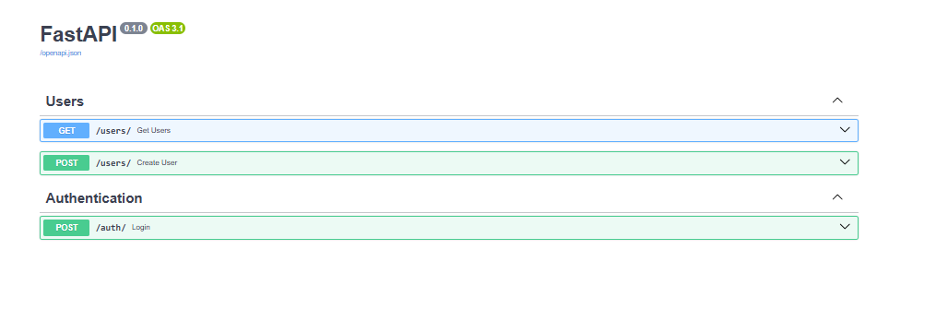
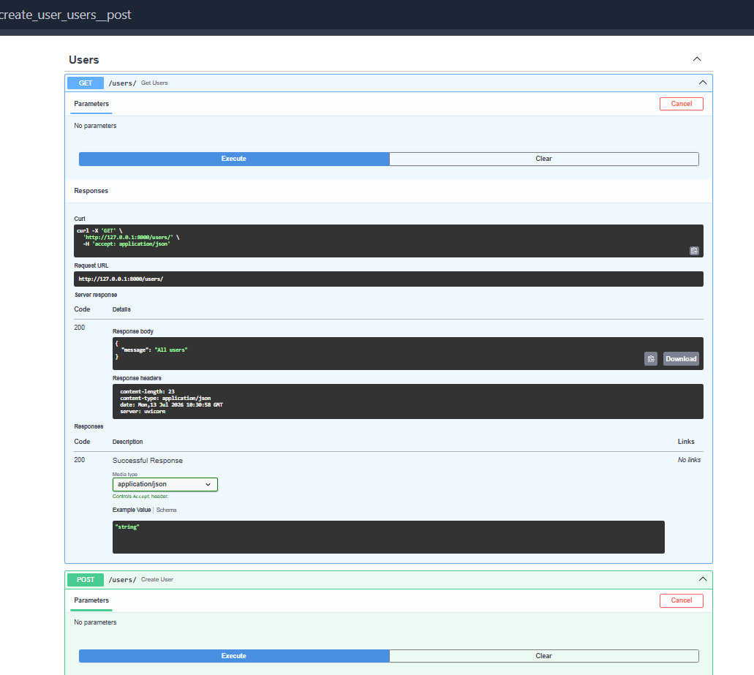
- Add a middleware that logs every request method, path, and response status code to the console.’
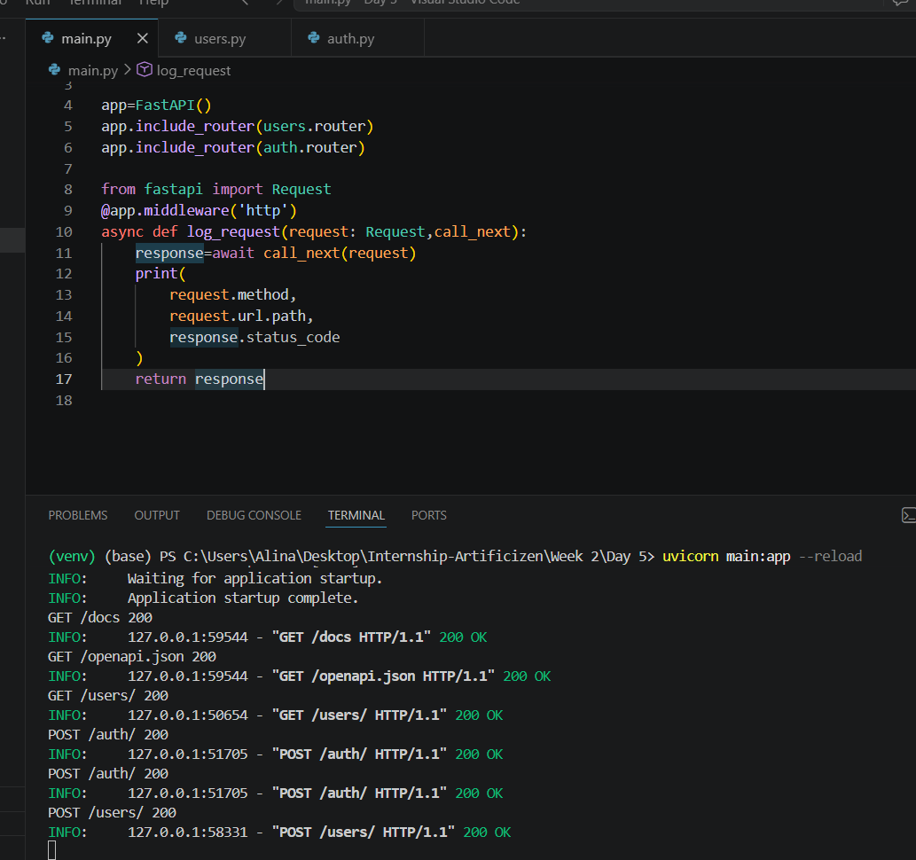
- Add CORSMiddleware configured to allow requests from http://localhost:3000 only.
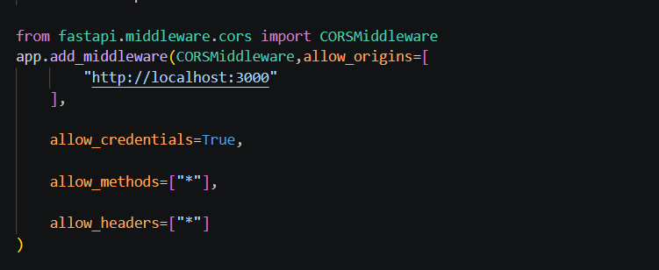
- Write a global exception handler for HTTPException that always returns JSON in the shape {"error": true, "detail": "...", "status": 404} instead of FastAPI’s default.
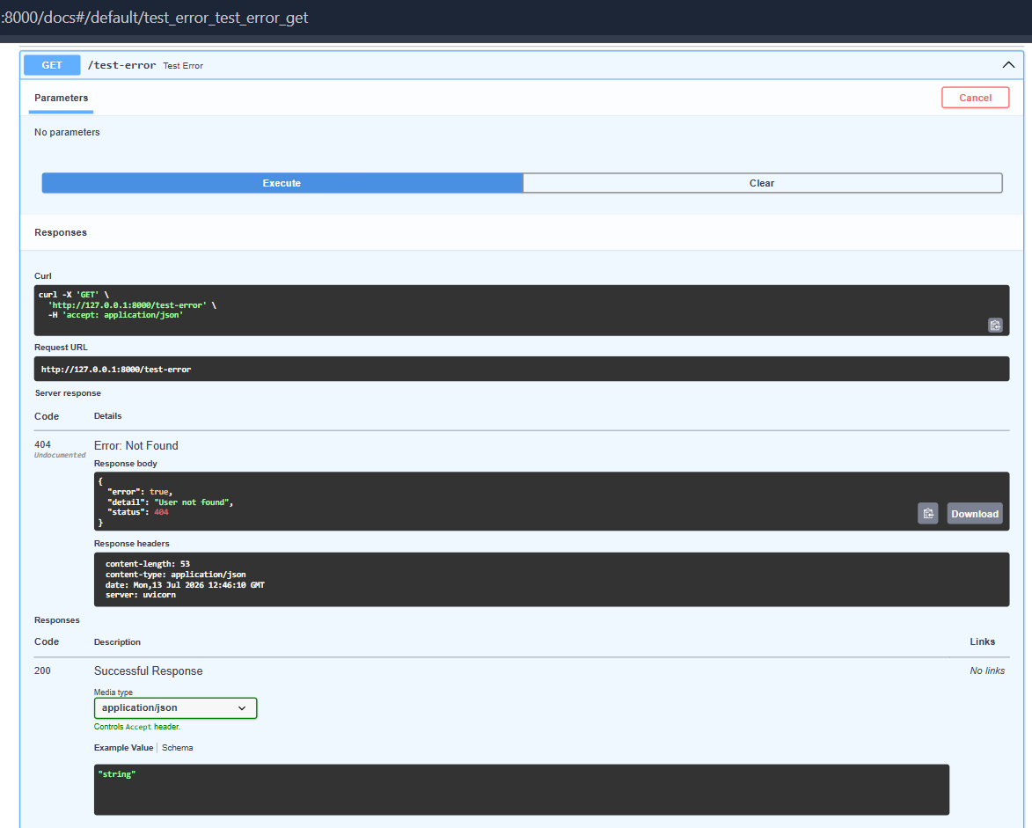
- Add a background task to the POST /users route that “sends a welcome email” (just print it) without blocking the response.
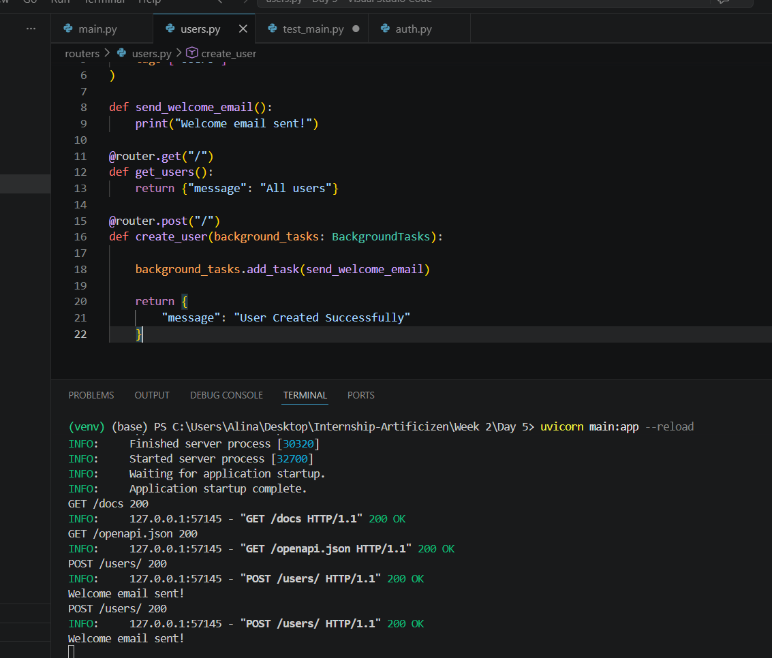
- Write at least three pytest tests using TestClient: one for a successful user creation, one for a duplicate email conflict, and one for a protected route returning 401 without a token.
